5. RecyclerView – Student List App

Topics covered:
RecyclerView, Adapter, ViewHolder, LayoutManager, Toast

Task:
• Display a list of students (Name + Roll No.) using RecyclerView
• On item click → show Toast with selected student name

Step 1: Create New Project
- Go to
File → New → New Project
- Select Empty Views Activity
- Click Next

Step 2: Project Details
- Project Name:
StudentRecyclerApp_Practical_5
- Language: Kotlin
- Minimum SDK: API 21 or above
- Click Finish

Step 3: Open activity_main.xml
- Go to
app → src → main → res → layout → activity_main.xml
- Click it
- Select Split tab (Code + Design)
- Replace existing XML with the following code:
- <?xml version="1.0" encoding="utf-8"?>
<androidx.recyclerview.widget.RecyclerView
xmlns:android="http://schemas.android.com/apk/res/android"
android:id="@+id/recyclerView"
android:layout_width="match_parent"
android:layout_height="match_parent" />
➡️ This layout contains only RecyclerView because it handles the entire list.

Step 4: Create Item Layout (item_student.xml)
- Right-click on layout folder
- Select New → Layout Resource File
- File name: item_student
- Root element: ConstraintLayout
- Click OK
Replace the XML with:
<?xml version="1.0" encoding="utf-8"?>
<androidx.constraintlayout.widget.ConstraintLayout
xmlns:android="http://schemas.android.com/apk/res/android"
android:layout_width="match_parent"
android:layout_height="wrap_content">
<LinearLayout
android:layout_width="match_parent"
android:layout_height="wrap_content"
android:orientation="vertical"
android:padding="16dp">
<TextView
android:id="@+id/txtName"
android:layout_width="wrap_content"
android:layout_height="wrap_content"
android:text="Student Name"
android:textSize="18sp" />
<TextView
android:id="@+id/txtRoll"
android:layout_width="wrap_content"
android:layout_height="wrap_content"
android:text="Roll No" />
</LinearLayout>
</androidx.constraintlayout.widget.ConstraintLayout>
➡️ This layout represents one row in RecyclerView.

Step 5: Open MainActivity.kt
- Go to
app → src → main → java → com.example.studentrecyclerapp_practical_5 → MainActivity.kt
- Open the file
- Add the following imports at the top:
import android.os.Bundle
import android.view.LayoutInflater
import android.view.View
import android.view.ViewGroup
import android.widget.TextView
import android.widget.Toast
import androidx.appcompat.app.AppCompatActivity
import androidx.recyclerview.widget.LinearLayoutManager
import androidx.recyclerview.widget.RecyclerView

Step 6: Add RecyclerView Code
Replace the existing code with:
class MainActivity : AppCompatActivity() {
override fun onCreate(savedInstanceState: Bundle?) {
super.onCreate(savedInstanceState)
setContentView(R.layout.activity_main)
val recyclerView = findViewById<RecyclerView>(R.id.recyclerView)
recyclerView.layoutManager = LinearLayoutManager(this)
val students = listOf(
"Amit - 101",
"Sneha - 102",
"Rahul - 103",
"Pooja - 104"
)
recyclerView.adapter = SimpleAdapter(students)
}
// Adapter inside MainActivity
inner class SimpleAdapter(private val studentList: List<String>) :
RecyclerView.Adapter<SimpleAdapter.ViewHolder>() {
inner class ViewHolder(view: View) : RecyclerView.ViewHolder(view) {
val txtName: TextView = view.findViewById(R.id.txtName)
val txtRoll: TextView = view.findViewById(R.id.txtRoll)
}
override fun onCreateViewHolder(parent: ViewGroup, viewType: Int): ViewHolder {
val view = LayoutInflater.from(parent.context)
.inflate(R.layout.item_student, parent, false)
return ViewHolder(view)
}
override fun onBindViewHolder(holder: ViewHolder, position: Int) {
val data = studentList[position].split(" - ")
holder.txtName.text = data[0]
holder.txtRoll.text = "Roll No: ${data[1]}"
holder.itemView.setOnClickListener {
Toast.makeText(
this@MainActivity,
data[0],
Toast.LENGTH_SHORT
).show()
}
}
override fun getItemCount(): Int {
return studentList.size
}
}
}

Step 7: Run the App on Emulator
- Click RUN ▶️
- App opens on emulator
- Student list is displayed
- Click on any item → Toast shows student name
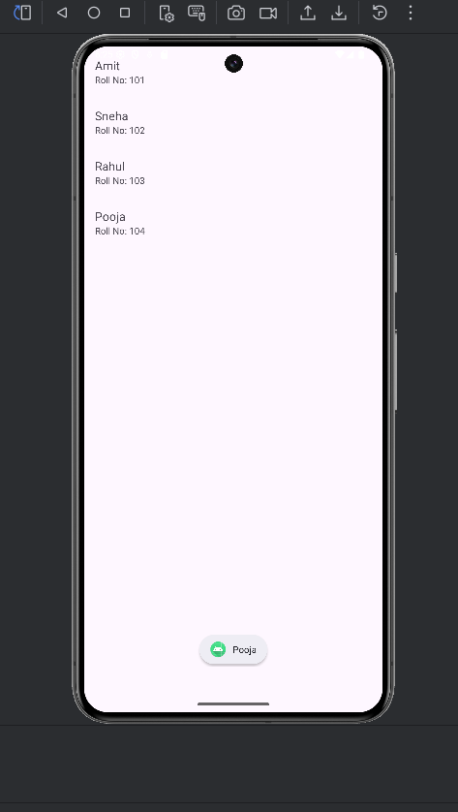

Step 9: Connect App to Actual Phone (Same as Practical 2)
- Open your phone → Settings
- Go to About device
- Tap Build Number 7 times
→ “You are now a developer!”
- Go back → Additional Settings
- Open Developer Options
- Enable USB Debugging
- Connect phone to laptop using USB cable
- Allow USB debugging permission
- Select your phone from device dropdown
- Click RUN ▶️

Output (Real phone):

